## *Summary*

In a fictionalized version of a Medieval Dark Fantasy Europe in the Kingdom of Bohemia was a weak king named Germaihn. The kingdom was small and was constantly under attack from northern barbarians and other forces. An ambitious and young individual of the time who had made a name for himself as a great warrior known as ***Barbarossa*** of the band of the Radiant Sun conquested easily over Germaihn’s forces and quickly rose to the position of King. He ruled for many years and grew the kingdom immensely as a dominant but unifying force. But grew distant overtime from his people and his royal advisors. Secluding to his studies, he heard of an abandoned prison on the corner of his grown kingdom that travelers had been talking about recently that intrigued him and made a visit. What he found was so enticing that he further became secluded in his studies, rejecting his royal responsibilities. The people became concerned for the well-being of their country and their beloved king. One day he disappears with rumors that he went back to the dungeon by himself. A bounty goes out for without their king this now great country will surely fall apart with the threat of surrounding kingdoms. The player plays as a variety of classes, all of which have their own personal reasons for wanting to visit the dungeon and interact with the King. Many other NPCs throughout the various kingdoms of this medieval Europa land are also there to aid or… not quite aid the player in this grand mission. Consider that the dungeon is a former prison but its inhabitants, the guards, other workers, prisoners, never did leave. Their fates have yet to be confirmed, maybe some are still out there to help the player *or not*. As the Dungeon goes down we start to abandon the idea of it being a place lived in and rather a place corrupted and maliciously twisted. Contorting space and time, the player may have to travel through abstract areas that may explain more of this corruptive void that has enveloped the dungeon. Maybe these secrets of this corruptive void are precisely why the King had a fascination in this place.

Each one of the [characters](https://docs.google.com/document/u/0/d/1YxFS7oqt7DW3lX-1MbuP4sY-uXh9HnmY5Q52fdS1rDk/edit) the player can pick has a different reason for coming to this dungeon. But it's all centered around this great man of high renowned of the time known as Barbarossa, this man is essentially Alexander the Great who took over a lot of this medieval world the game takes in but developed a deep fascination for these dungeons, he headed in alone a while ago and hasn't come out so there is a bounty for him, some characters want to kill him themselves for what he did to their home countries, or some are fascinated witBarbarossasa’s desire for this strange place.

Initial story will be mostly communicated to the player at first through [opening character choices,](https://docs.google.com/document/u/0/d/1YxFS7oqt7DW3lX-1MbuP4sY-uXh9HnmY5Q52fdS1rDk/edit) NPC interactions, environmental storytelling, and item descriptions.

(Example down below with additional lore and actors in the story)

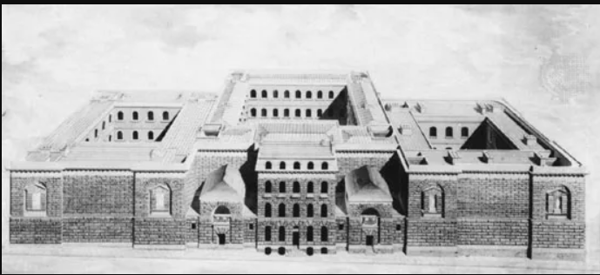

Newgate Prison England^

Reference for Dungeon Level 1

Safe areas for Level 1 will be the courtyards to the left and right sides where players can ‘clear’ enemies off and permanently be safe areas where you can find NPCs in the world and send them to. Center courtyard will need to be unlocked through complete exploration of level 1, need to clear center courtyard and beat boss to go further into the dungeon.

NPC List

—---- Currency is the same for merchants and leveling player character—-----------

Merchant NPC - Heals, Mana, keys (for shortcuts probs not progression), other utility items

Smith NPC - Using currency and upgrade items to upgrade favorite items for big damage

Lore NPC - Flavor text person // world building

Questline NPC - Offers player a choice to aid character in their mission, will benefit player with items, or assistance in a boss fight

Training Dummy NPC - Player can fight a training dummy to test new items, see damage numbers

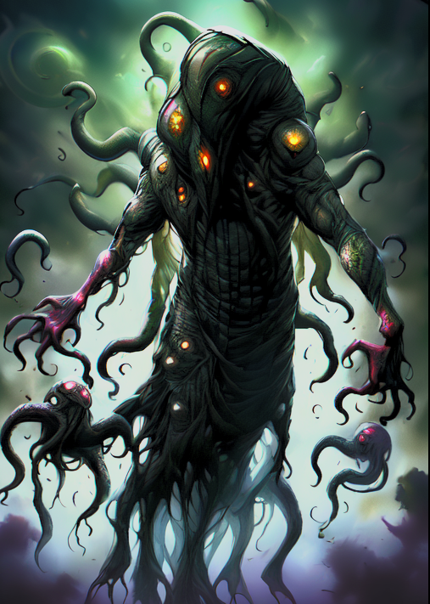

Potential Reference for Bosses 1-3 ‘The Corruptor’

The source of the dungeon’s corruption, a being that seeks to expand its influence beyond the dungeon walls. A formless mask of dark energy that occasionally takes a vaguely humanoid shape, with tendrils of corruption extending into the surrounding area. This boss shifts the battlefield by creating tendrils that must be avoided, launches bursts of dark energy, spawn in basic enemies, and can temporarily envelop itself in a shield of corruption. Players need to target weak points that appear on The Corruptor’s body to break its shield before dealing damage. This boss is relatively large with high health and damage, and it is only weak to holy damage.

The Corruptor will be the boss of all 3 floors. They will escape after the first 2 boss fights, but be slain during the last battle.

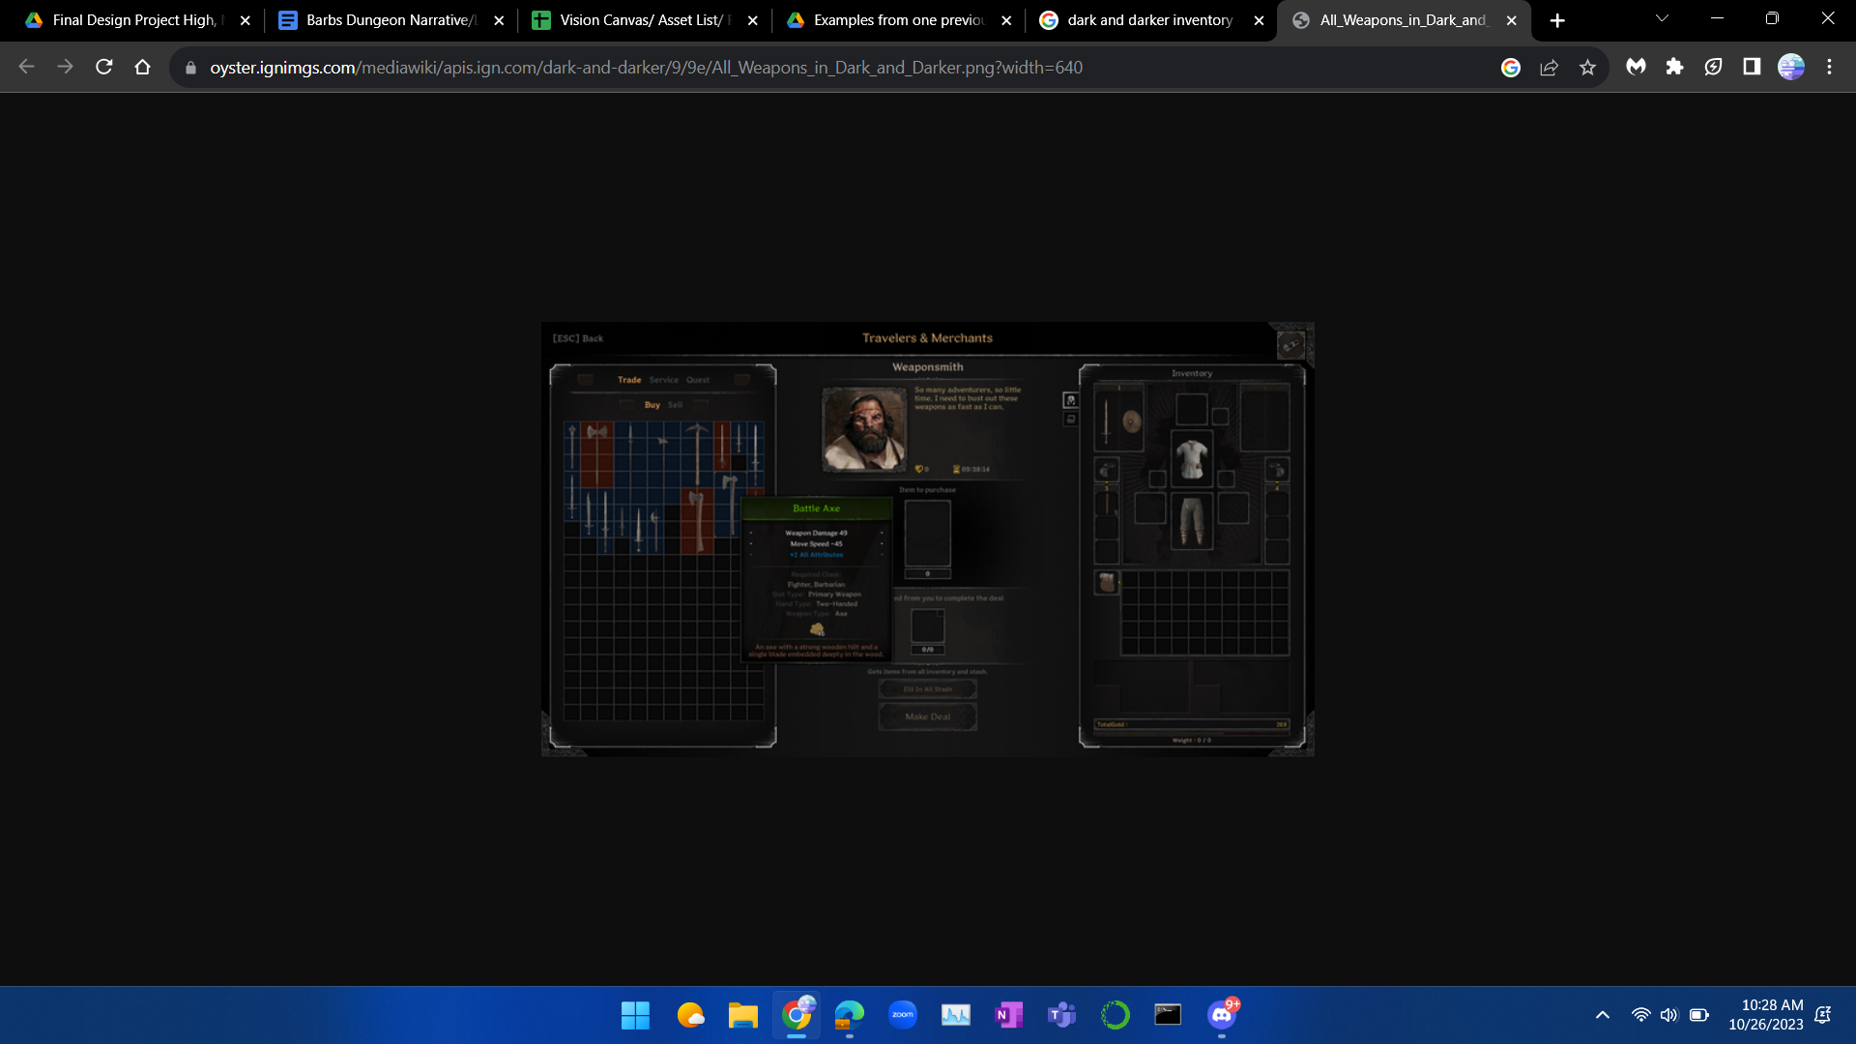

Inventory Reference

Ranger - Character Lore and Concept of opening dialogue and choices

* ‘You came from a family of no renown, every day was difficult surviving, and caring for your younger siblings. Your parents weren’t around so it was up to you to provide no matter the cost.’
* Option 1: Rogue (Shadow Strike, Poison Dart)
* Option 2: Archer (Piercing Shot, Volley)
* Option 3: Beastmaster (Feral Charge, Primal Howl)

Knight - Character Lore and Concept of opening dialogue and choices

You grew up in the kingdom of Bohemia, you remember the rise and fall of King Germaihn. But he was nothing compared to the larger the life figure that was Barbarossa. Once a young mercenary, he rose to power through sheer determination and ambition. Overthrowing Germaihn, Barbarossa ruled Bohemia for many years and you had always looked up to him. You wanted to serve your king so you entered the infantry and excelled at the top of your class, you got to choose what role you would fill in Barbarossa’s army.

* Option 1: Paladin (Enchanting Weapon, Lesser Heal)
* Option 2: Berserker (Frenzy, Berserker’s Rage)
* Option 3: Commanding General (Commanding Shout, Knight’s Loyalty)

Mage/Wizard- Character Lore and Concept of opening dialogue and choices

You always had a talent for the arcane arts. But such talent can not go without upheaval, you were physically very weak. Receding into your studies for many years made you become very distant from mankind. But there’s only so much knowledge for a singular mind to obtain. What do you decide to focus your time on?

* Option 1: Divine Channeler (Enchanting Weapon, Lesser Heal)
* Option 2: Chaos Sorcerer (Fireball, Chain Lightning)
* Option 3: Summoner (Lesser Conjured Bow, Lesser Conjured Shortsword)

Assassin Character Lore and Concept of opening dialogue and choices

Veiled in shadows, your existence is a whispered legend. A ghost in the alleyways, you’ve learned to survive where others fear to treat.

* Option 1: Shadowblade (Silent Strike, Smoke Bomb)
* Option 2: Swiftstrike (Dash Stab, Momentum Shift)
* Option 3: Venomancer (Venomous Blade, Infiltrate)